ST. XAVIER’S COLLEGE

**(Affiliated to Tribhuvan University)**

Maitighar, Kathmandu



**Computer Graphics Lab Assignment #2**

**To Make a Simple Calculator**

**Submitted by:**

Arun Sanjel

013BSCCSIT010

**Submitted to:**

|  |  |
| --- | --- |
| Er. Anil K. Sah  Lecturer, St. Xavier’s College |  |

**STATEMENT:**

To Make a Simple Calculator

**SOURCE CODE:**

//---------------------------------------------------------------------------

#include <vcl\vcl.h>

#pragma hdrstop

#include "Calc.h"

//---------------------------------------------------------------------------

#pragma resource "*.dfm"

TForm1 *Form1;

int X,Y,oper;

//---------------------------------------------------------------------------

__fastcall TForm1::TForm1(TComponent* Owner)

: TForm(Owner)

{

}

//---------------------------------------------------------------------------

void __fastcall TForm1::butClick(TObject *Sender) // Numeric input

{

displayPanel->Text=((TButton *)Sender)->Caption;

X=StrToInt(displayPanel->Text);

}

//---------------------------------------------------------------------------

//---------------------------------------------------------------------------

void __fastcall TForm1::butPlusClick(TObject *Sender)

{

displayPanel->Text="";

oper=1;

Y=X;

}

//---------------------------------------------------------------------------

void __fastcall TForm1::butSubClick(TObject *Sender)

{

displayPanel->Text="";

oper=2;

Y=X;

}

//---------------------------------------------------------------------------

void __fastcall TForm1::butMulClick(TObject *Sender)

{

displayPanel->Text="";

oper=3;

Y=X;

}

//---------------------------------------------------------------------------

void __fastcall TForm1::butDivClick(TObject *Sender)

{

displayPanel->Text="";

oper=4;

Y=X;

}

//--------------------

void __fastcall TForm1::butEqualsClick(TObject *Sender)

{

switch(oper){

case 1:{

displayPanel->Text=(X+Y);

}

case 2:{

displayPanel->Text = (X-Y);

}

case 3:{

displayPanel->Text = (X*Y);

}

case 4:{

displayPanel->Text = (X/Y);

}

}

//displayPanel->Text = temp;

}

**OUTPUT:**

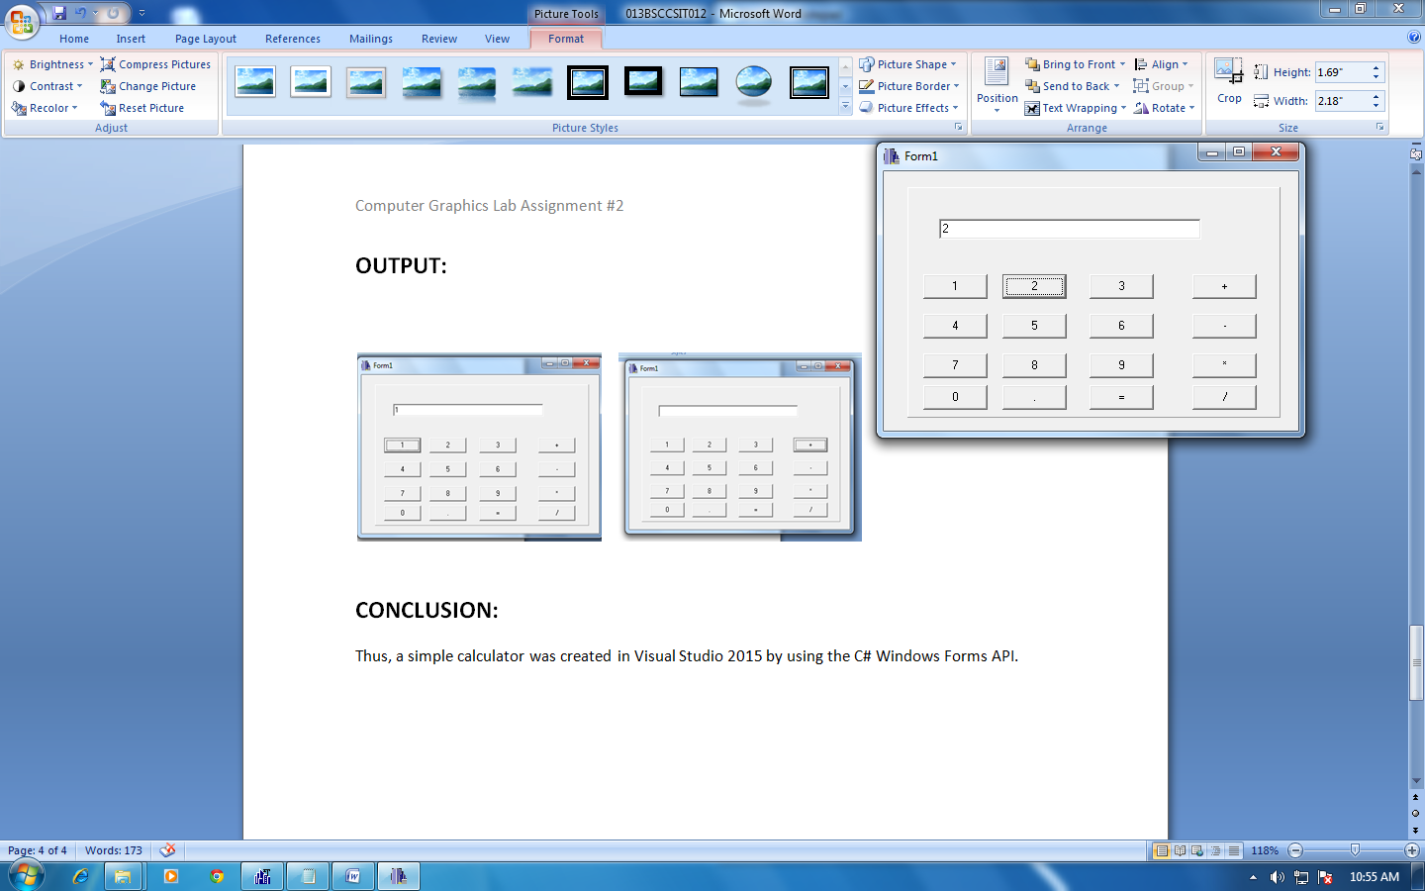

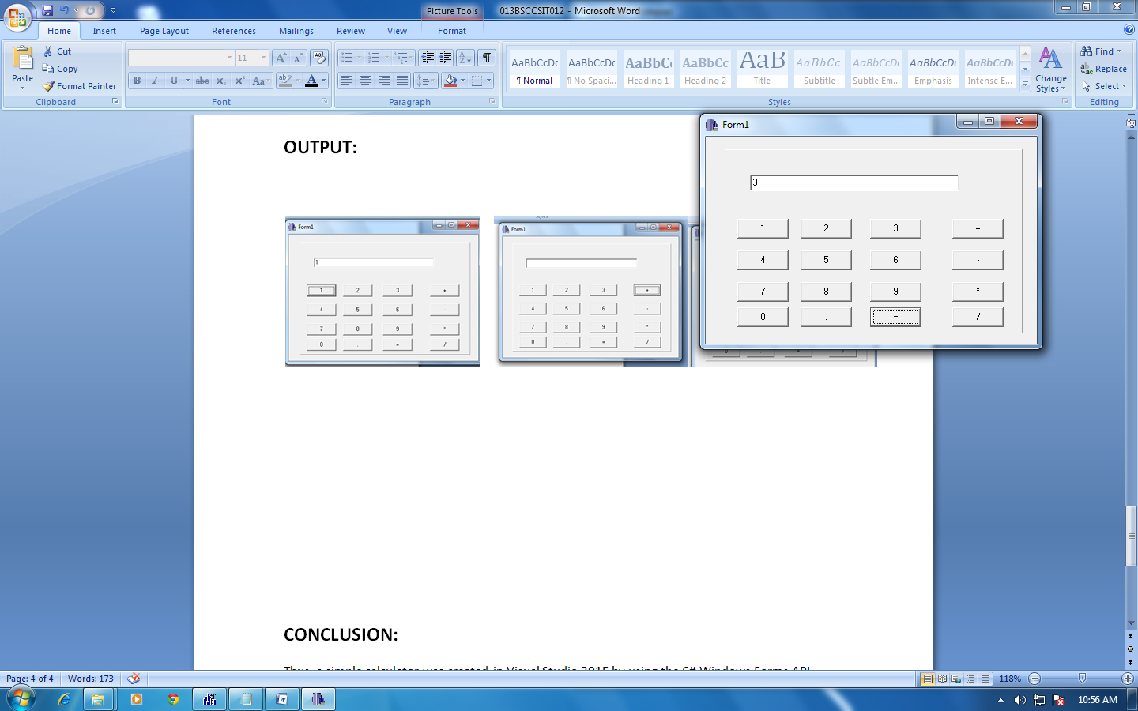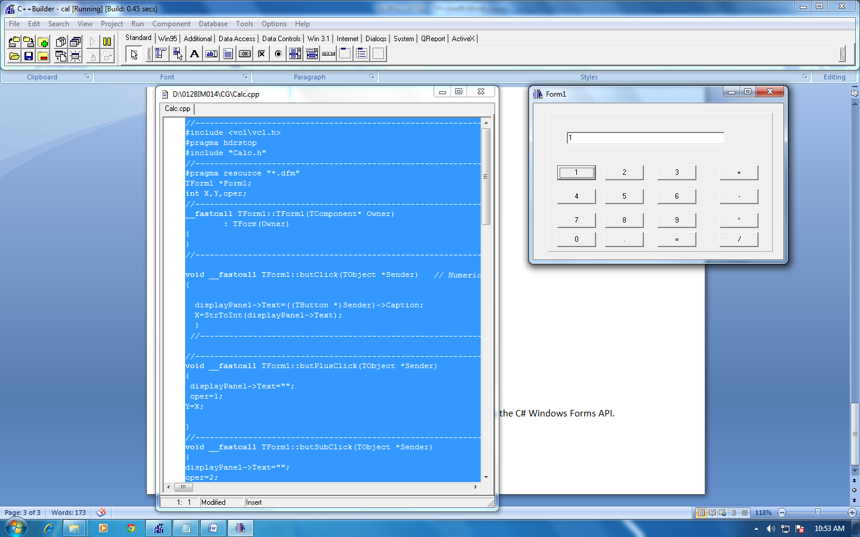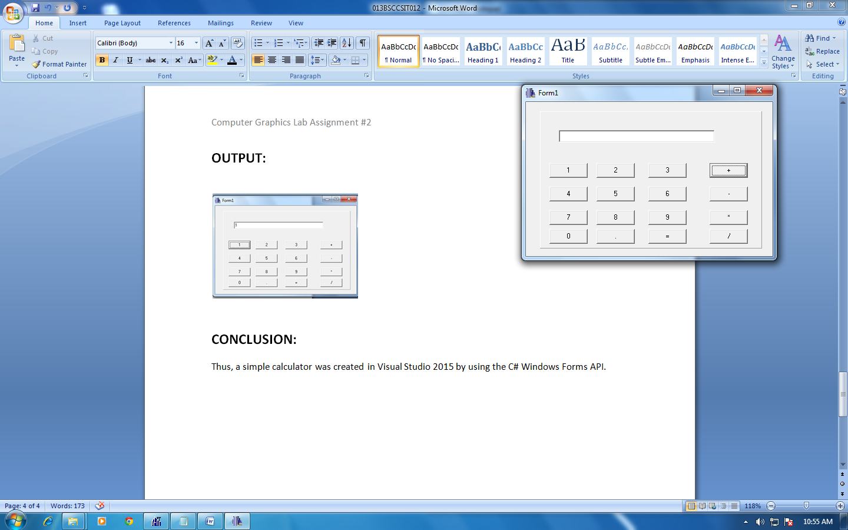

**CONCLUSION:**

Thus, a simple calculator was created in C++ builder .